Virtual Network Peering

Here's a step-by-step guide on setting up Azure Virtual Network Peering:

Step 1: Sign in to the Azure Portal

- Navigate to the Azure portal (portal.azure.com).
- Sign in using your Azure account credentials.
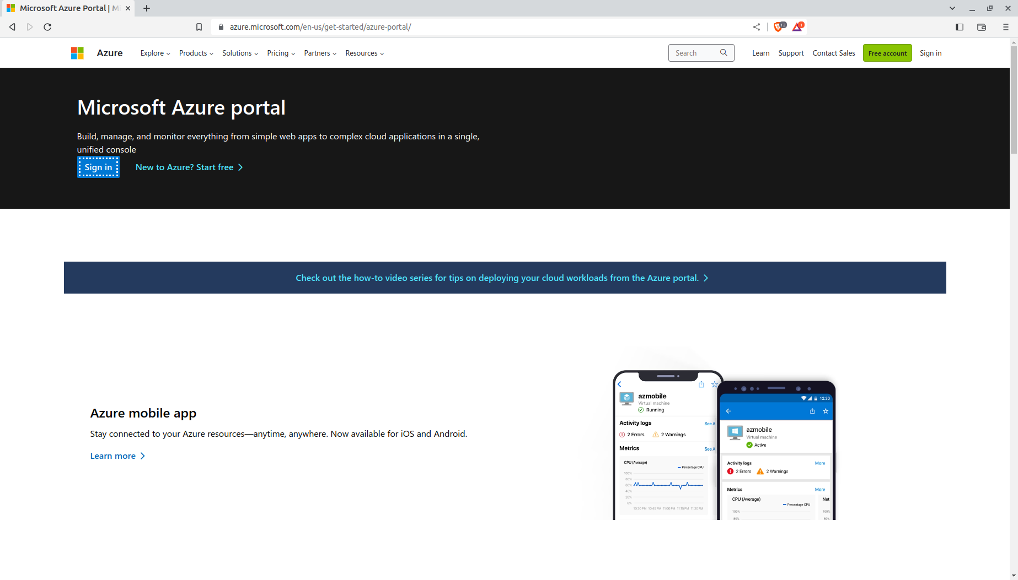

Step 2: Create Virtual Networks

1. On the Azure portal home page, click on the "Create a resource" button.
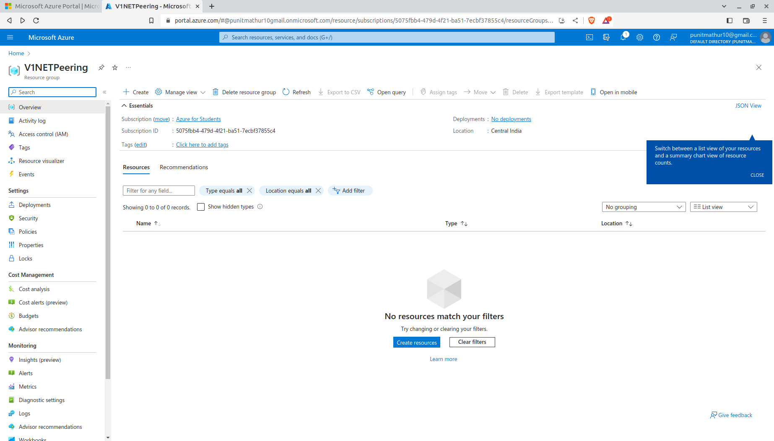

2. Search for "Virtual network" in the search bar and select "Virtual network" from the results.

3. Click on the "Create" button to start the virtual network creation process.

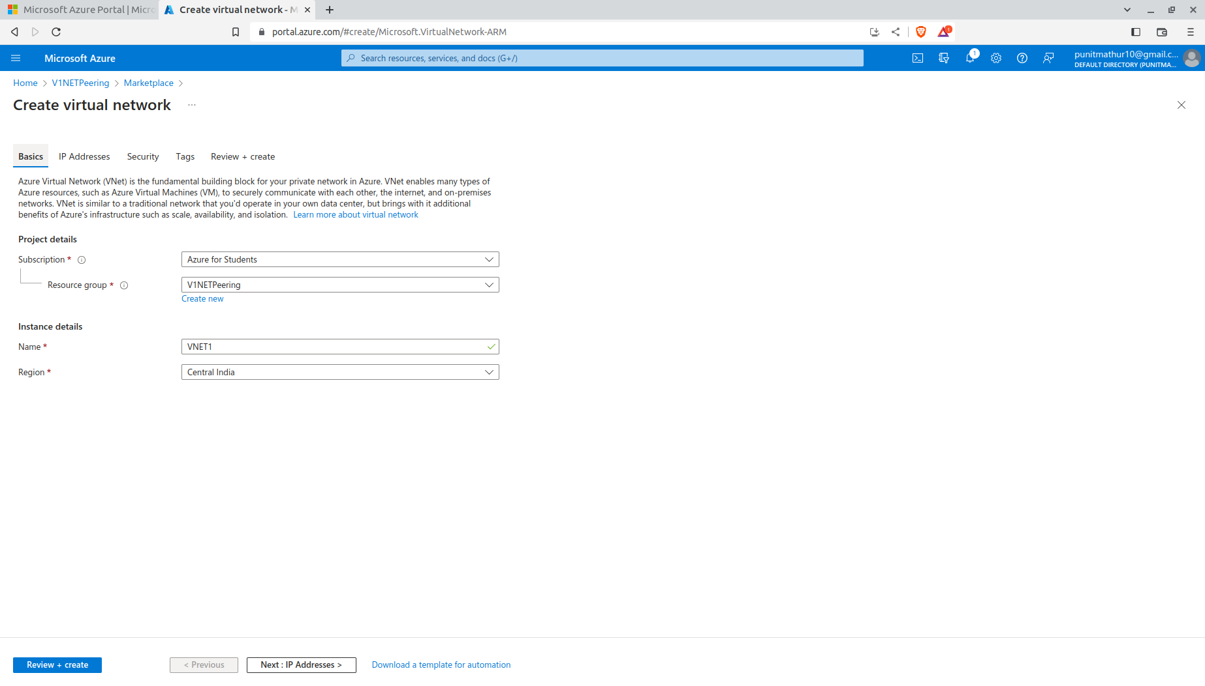

4. Enter the required details such as a unique name for the virtual network, IP address space, and subnet configuration.

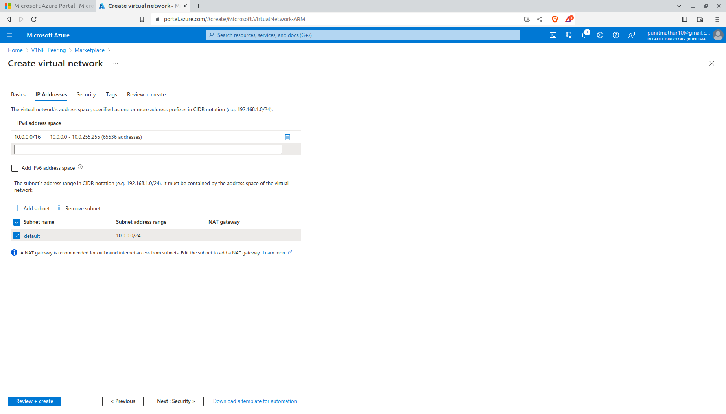

5. Configure other settings as per your requirements.
6. Click on the "Create" button to create the virtual network.
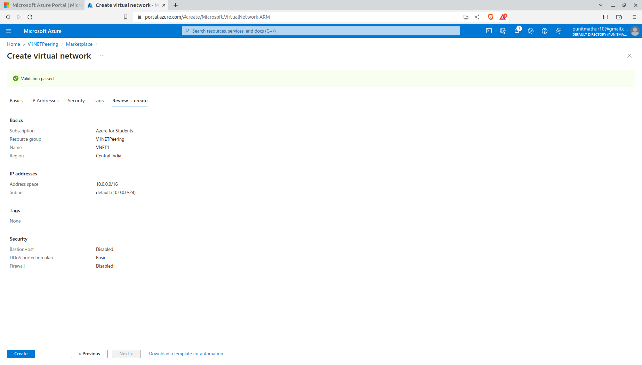

7. Your Virtual Network VNET1 is Created
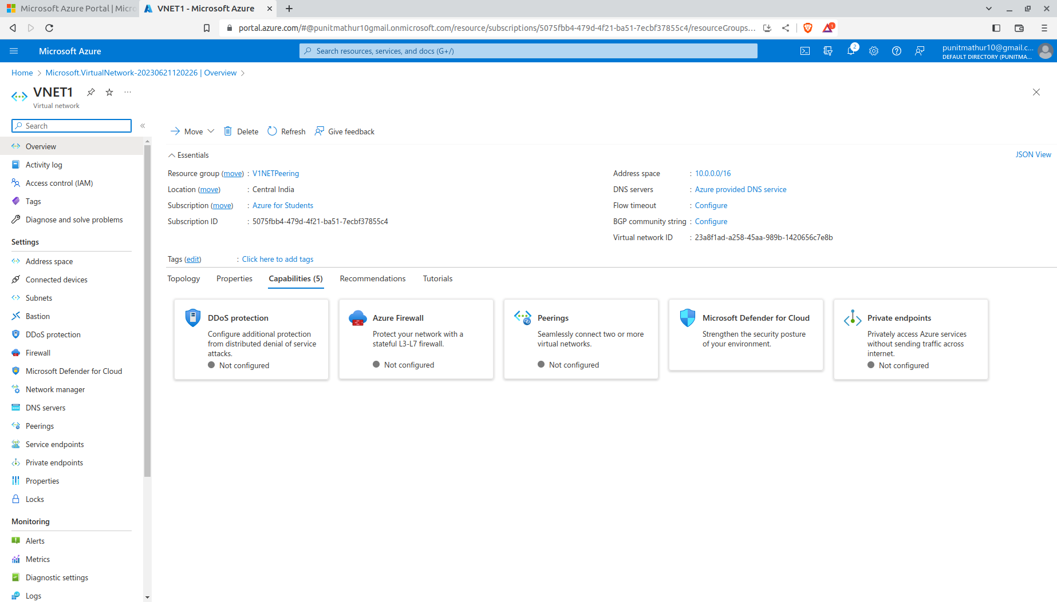

Note :- All the above steps will be repeated to create VNET2 as well.

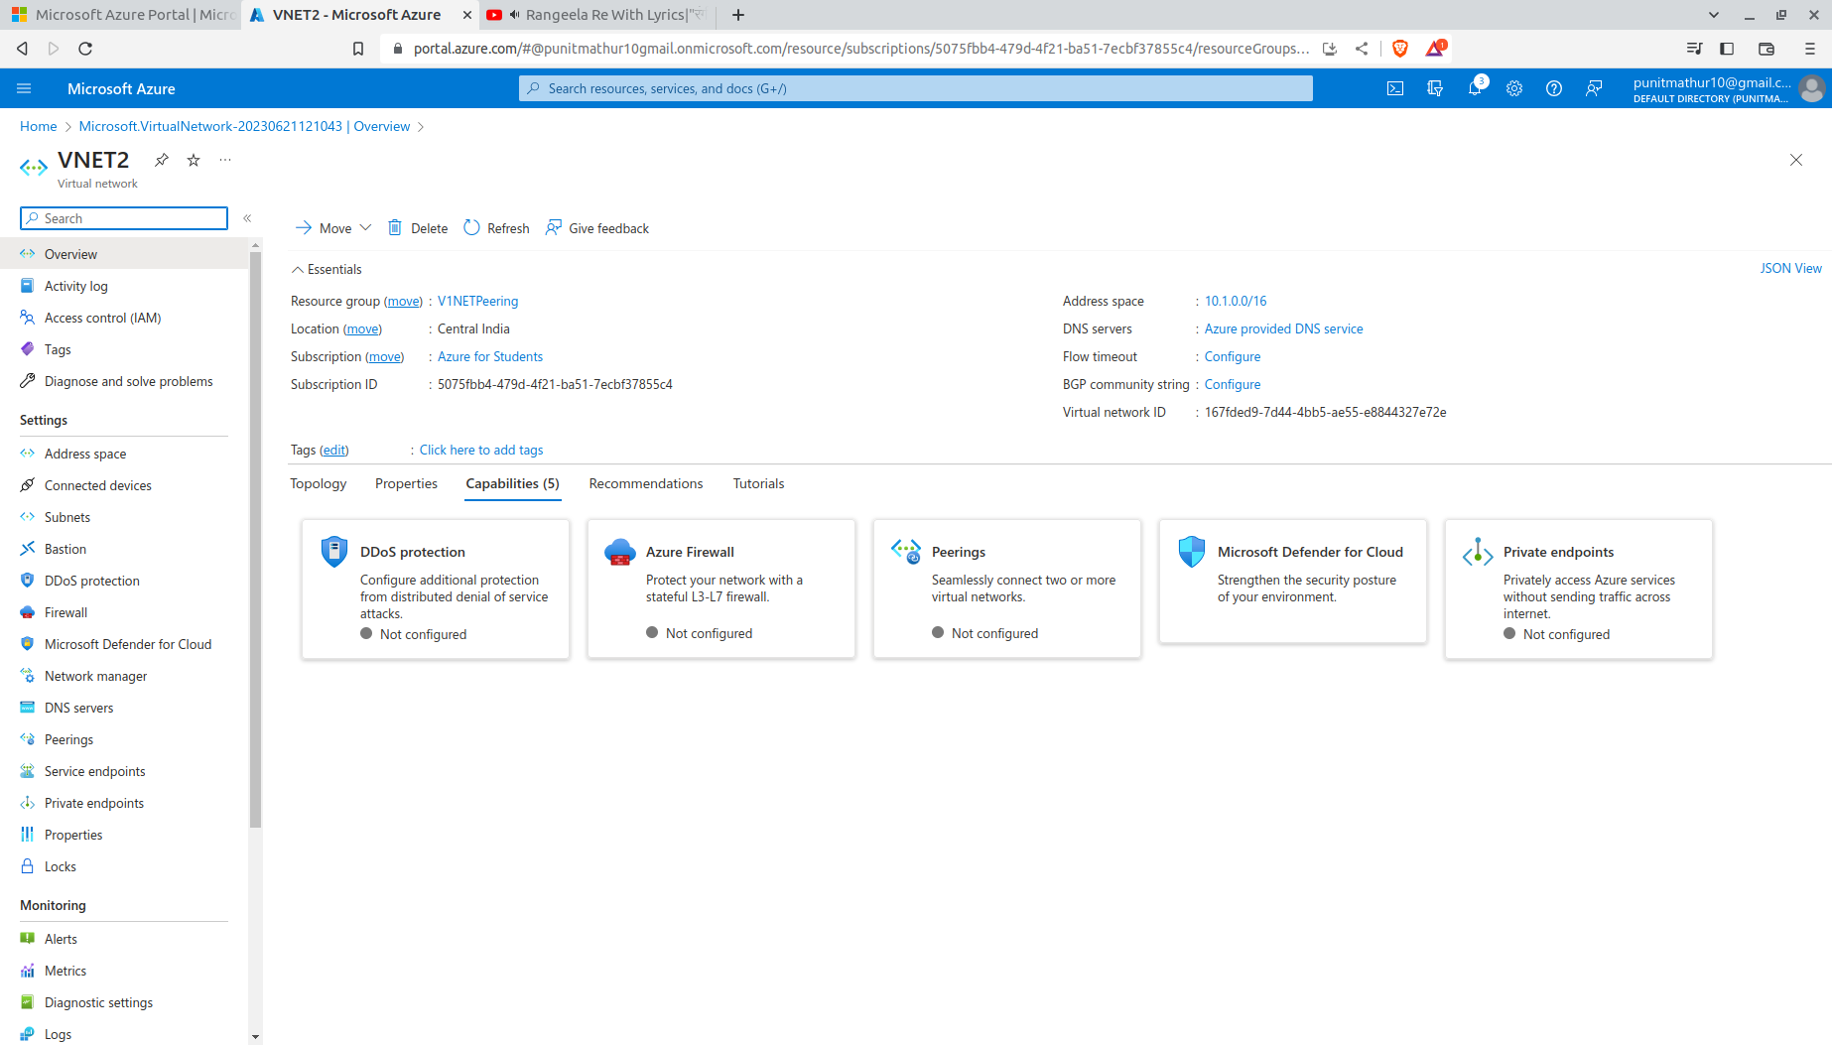

Step 3: Peer Virtual Networks

1. Once the first virtual network is created, go to the Azure portal home page.

2. Repeat steps 2-6 from the previous section to create another virtual network with a unique name and IP address space.

3. After the second virtual network is created, navigate to the "Virtual networks" section in the Azure portal.

4. Select the first virtual network that you created.

5. In the virtual network overview page, click on the "Peerings" tab and then click on the "Add" button.

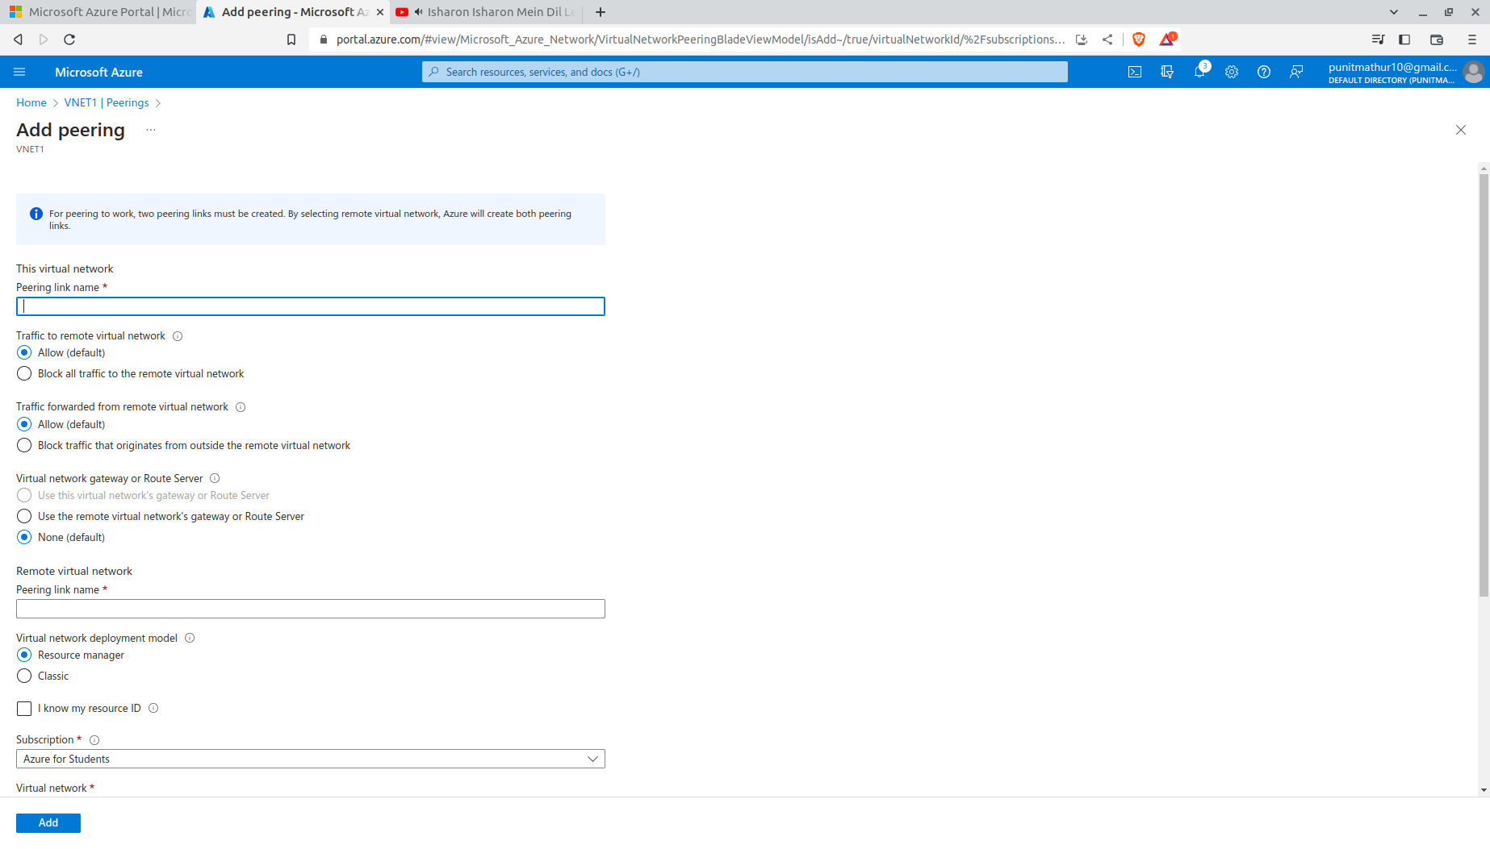

6. In the peering configuration, select the second virtual network as the remote virtual network.
7. Configure the peering settings, such as a unique name and allow or deny access between the networks.
8. Click on the "OK" button to create the virtual network peering.
